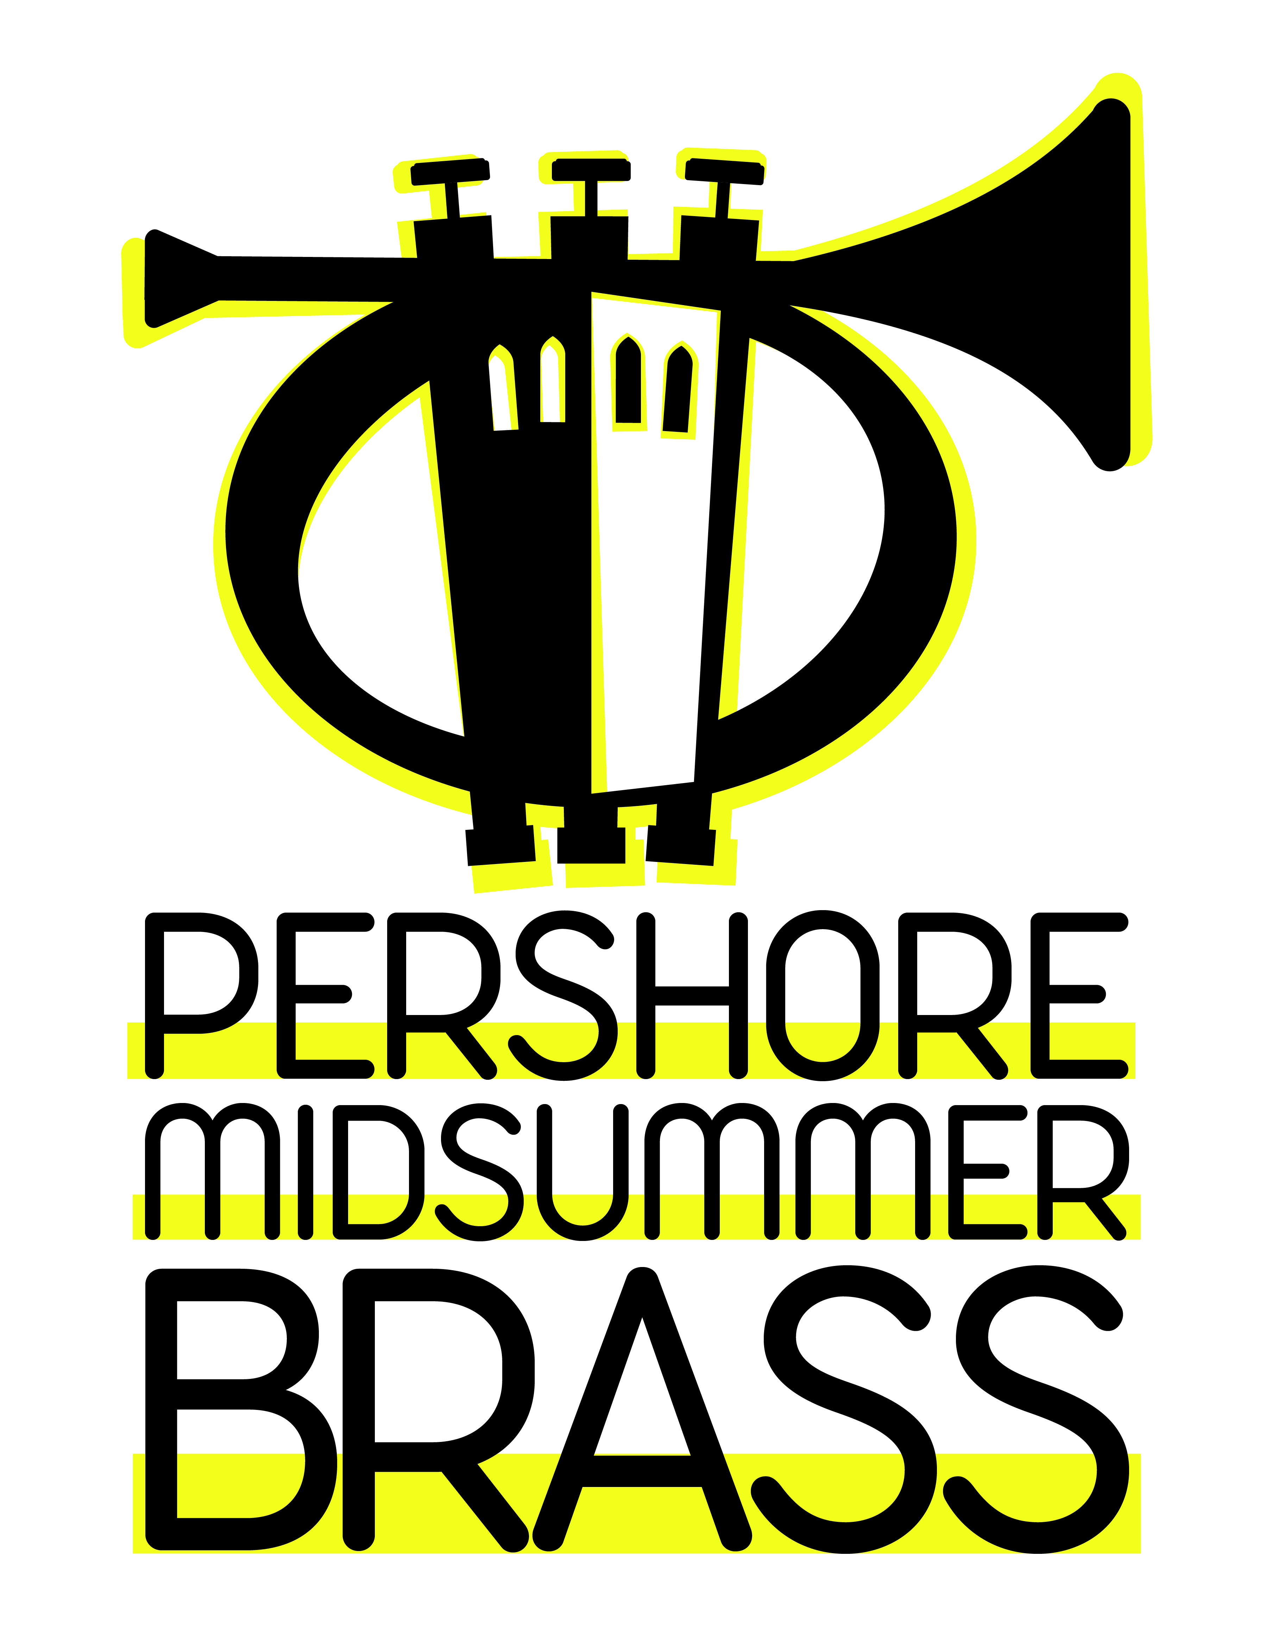

The support of advertisers is a greatly valued help to the success of our event.

Advertising Rates | Sponsorship Rates
Advert Type Size Cost  1 Full Page Rear Cover £120  2 Full Page Inside Rear Cover £110  3 Full Page Inside Front Cover £110  4 Full page £90  5 Half Page £60  6 Quarter Page £35  7 Include a Web link/advert £25 | Championship Band 2 performances* £360.00  Championship Band 1 performance £185.00  1st/2nd Section Band 2 performances* £250.00  1st/2nd Section Band 1 performance £130.00  Other Band 2 performances* £170.00  Other Band 1 performance £85.00  *- includes a FULL page advert in the programme & Advertising on our website / web link
Advert Details
Details of Business  Including Point of Contact | Full Address  (for Billing) | Type of Advert Required | Copy Provided  (Yes/No) | Same as last year  (Yes/No) | Comments

Sponsorship Details
Amount Sponsored
Which band is to be sponsored (if known)
Contact Details of Sponsor

Payment by BACS: A/c Name: Pershoremidsummerbrass. Sort Code 30-93-11 A/c No. 01303710

____________________________________________________________________________________

